**Task 1:**

Check whether /user/acadgild directory exists or not in the HDFS.

If it doesn't exist, then create this.

Create a directory /user/acadgild/hadoop.

**Output :**

1. We ran follwing command for output:

[acadgild@localhost]$ Hadoop fs –test –d /user/acadgild

1. For checking result above command , weran below command

[acadgild@localhost]$ echo $?

Above command return value 0 means the directory /user/acadgild is exist.

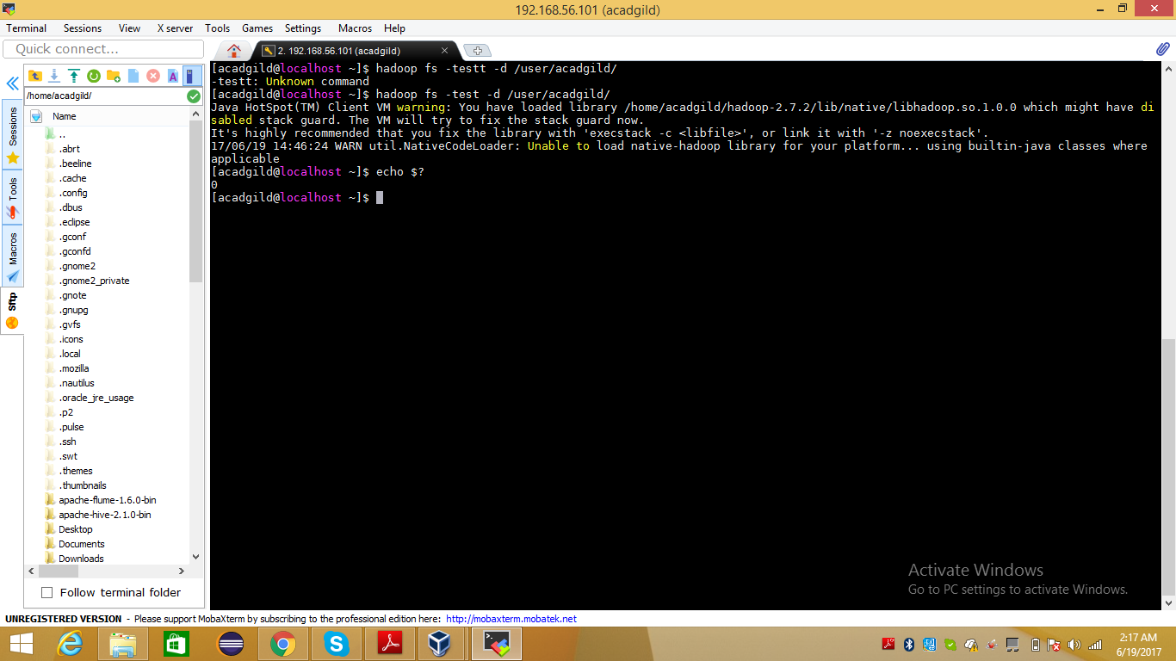

**Task 2:**

Create a file in HDFS under directory /user/acadgild/hadoop, with name word-count.txt.

Whatever we type on screen should get appended to the file.

Try to type (on screen) few lines from any online article or textbook.

**Output :**

1. To create file word-count .txt on HDFS, we ran below command

[acadgild@localhost]$ hadoop fs -touchz /user/acadgild/hadoop/word-count.txt

1. ran below command to display text on screen(initially file is empty)

[acadgild@localhost]$ hadoop fs -cat /user/acadgild/hadoop/word-count.txt

1. Ran below command to create and input text on screen on file on local system.

[acadgild@localhost]$ cd Documents

[acadgild@localhost]$ cat > word-count.txt

1. Ran beow command to append data to HDFS file

[acadgild@localhost]$ hadoop fs -appendToFile word-count.txt /user/acadgild/hadoop/word-count.txt

1. Ran below command to display text on screen(now file has some data)

[acadgild@localhost]$ hadoop fs -cat /user/acadgild/hadoop/word-count.txt

Output screen shot on next page

